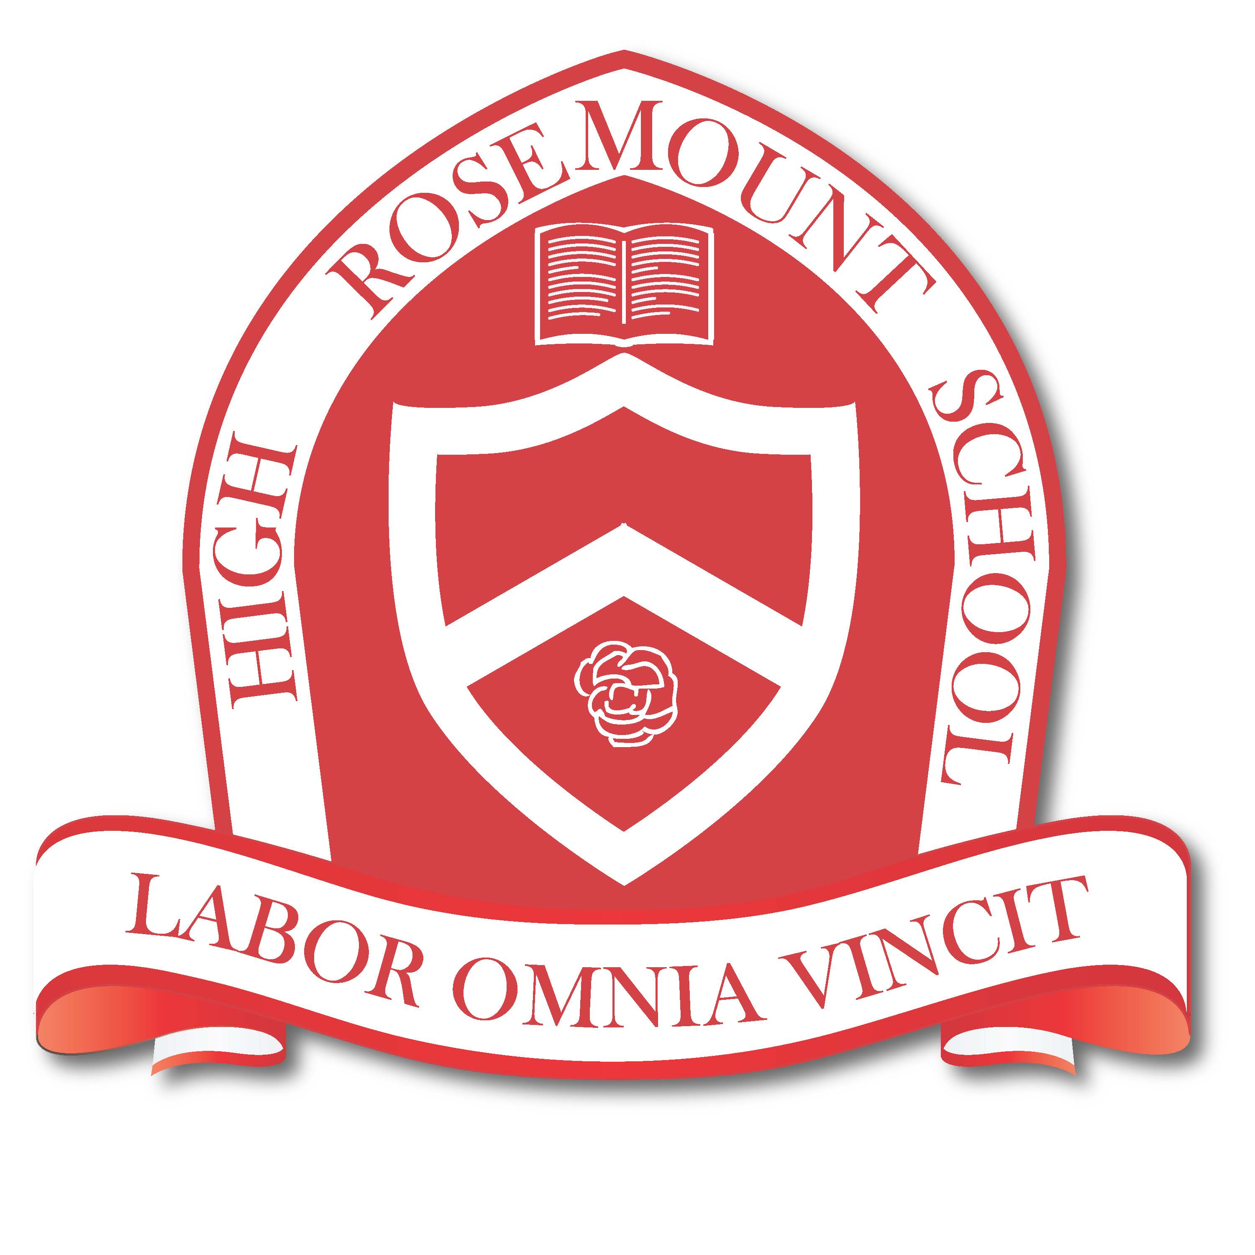

Mission Statement

Rosemount High School is committed to preparing its students to be responsible,
productive, and bilingual members of society. Students are encouraged
to reach their full potential academically, morally and socially.
In a secure, multicultural setting, students learn to be respectful and appreciative of themselves and others. We strive to develop self-esteem, self-respect and self-discipline within each student.
"Labor Omnia Vincit” – Hard work conquers all…this is the official motto of our school.

Rosemount High School
Open the door to your future!
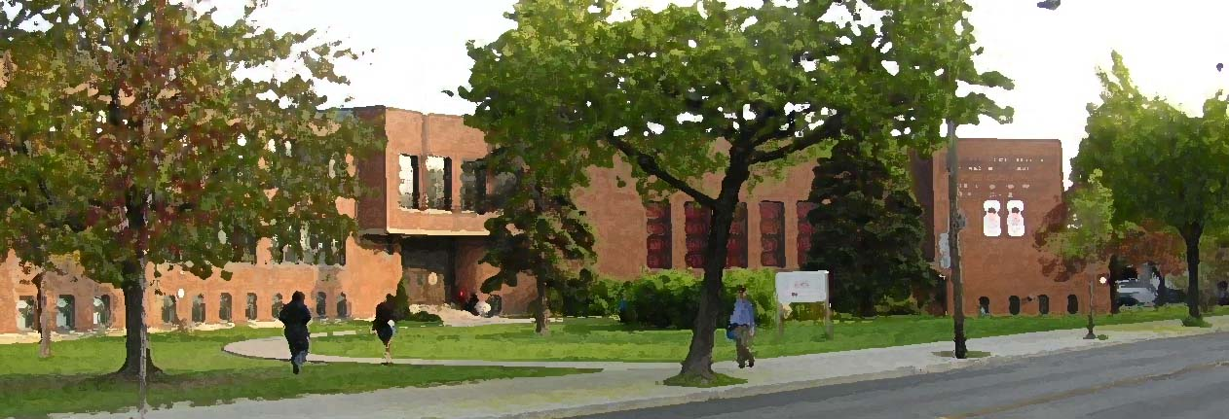

Open House

Thursday October 3th, 2019, 7:00-9:00 PM

Placement Exam for Secondary 1:
May 23th, 2020 at 9:00 AM

Coffee & Refreshments in the Learning Commons (Library) as of 7:45 PM

Welcome to Rosemount High School

Rosemount High School is committed to providing an environment where all students can find their abilities and realize their potential. Our variety of programs provide a unique opportunity for students to benefit from a multi-disciplined approach to their education. From Athletic Leadership to Music Concentration, we offer a wide palette of experience for your child.

We mainly service the boroughs of Rosemont, St. Michel, Parc-Extension, St. Leonard, and Montreal North. The school is easily accessed by taking Bus #18 (east) from the Beaubien metro or Bus #67 from the St. Michel metro connecting to Bus #18 (east) on Beaubien. Though we are an east-end school, we have students coming from as far as the West Island, Laval and Pointe-aux-Trembles.

Parent Involvement

Our parents are involved in the Music Parents’ Association and school Governing Board. They are set up in front of the Auditorium and in the 3400 Plaza (respectively) and are available and happy to answer any of your questions about the importance of parental involvement.

Rosemount High School – A Snapshot

- Unique music concentration program
- French immersion program
- Guidance and career counselling
- House Leadership Program
- New weight room
- Special education support
- After-school homework program
- Lunchtime and after-school activities and clubs
- Advanced math and science
- Trips and excursions; carnival week; concerts; musicals
- Active participation in inter-scholastic sports (GMAA)
- School uniform
- Junior School Model and much more!

For More Information

Pay us a visit: 3737 Beaubien Street East
Give us a call: 514-376-4720
Email us: rosemount@emsb.qc.ca
Visit us online: www.emsb.qc.ca/rosemount
Like us on Facebook: www.facebook.com/RHSmontreal
Follow us on Twitter: www.twitter.com/rosemounthigh

My Notes

Third Floor Map

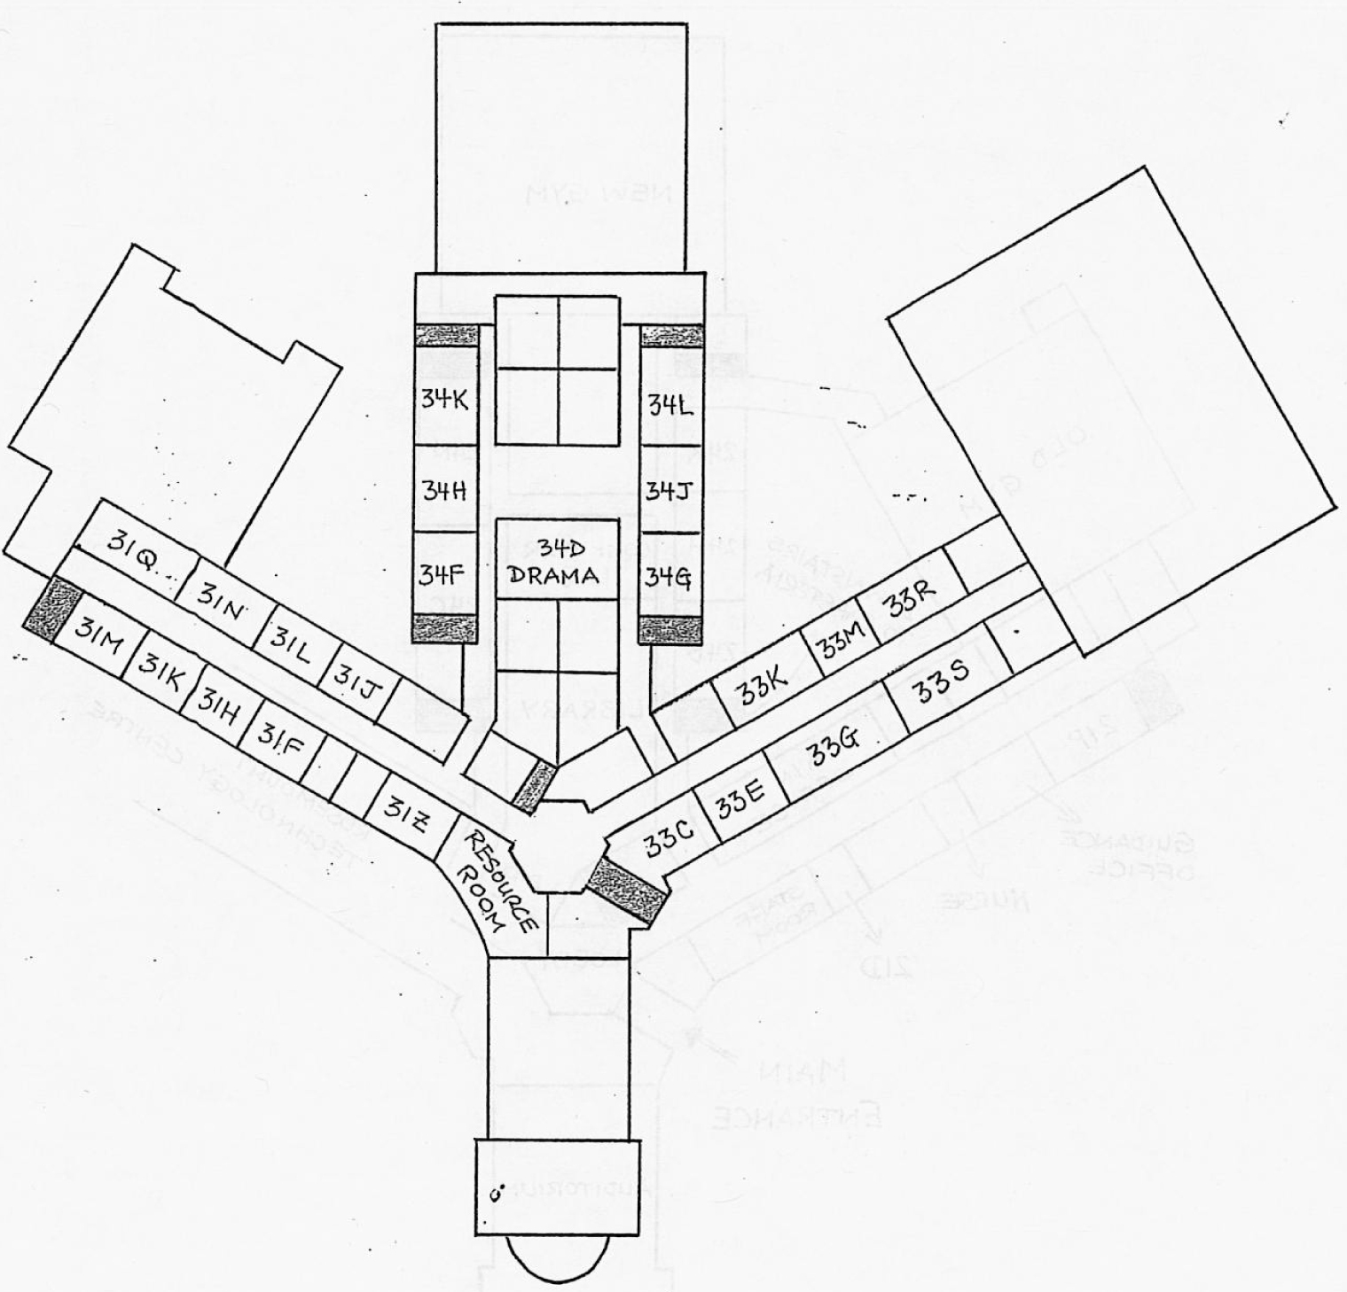

Open House Program

Open Art Studio Location: 24N
Take a tour of an exhibit of student artwork; watch a slideshow of unique, creative, and beautiful past projects, and an interactive art activity.

Département de Français Location: 24K
Présentation des programmes, resources, matériel et projets.

Sciences Location: 33K
Take a tour of our science facilities and watch students perform chemistry experiments.

Music Program Location: Auditorium
Take in the sounds of music with our mini performances which will be taking place throughout the evening, starting with our Symphonic Winds ensemble.

Social Studies Exhibit Location: 24H
Take a tour and enjoy seeing models and projects from our History department; get your questions answered about our other social science offerings.

Physical Education Location: New Gym
Watch practices and games from our student-athletes.

English Language Arts Location: 21F
Get information on curriculum materials, book club, spelling bee competition, and more.

Mathematics Department Location: 21P
Puzzles for kids; Get information on curriculum and resources, and what it takes to study advanced-level mathematics.

Dramatic Arts Location: 34M (Drama Room)
Get information about our Drama curriculum and the extra-curricular projects that enhance the classroom experience, including school musicals.

Français enrichi/ Junior School Location: 24B
Renseignements sur notre programme enrichi et notre modèle « Junior School ».

KIOSKS

Guidance & Career counselling Location: Guidance
It’s never too early to get questions answered about career exploration programs for your child, graduation requirements, and post-secondary options and pre-requisites.

Spiritual & Community Programs Location: 21D
Mind, body, spirit – speak to our Spiritual and Community Animator about programs that go beyond academics in order to educate the whole child.

Resource Location: Guidance
Every child learns difficulty and sometimes they need a little extra support. Come and meet our team of teachers that will work with your child to ensure their success.

Our Facilities

- Auditorium with brand new theatre seats, capacity of 762.
- Two (2) gymnasiums one that was recently completed renovated
- Full service cafeteria.
- Large outdoor soccer field; large oval running track across the street.
- Very spacious Learning Commons (library) that is catered to the 21st century
- Three (3) well-equipped science labs.

Registering at Rosemount

Our full registration package for 2019-2020, as well as a checklist of required documents, can be downloaded from our school website. You can also pick up a registration package from the school’s main office. The registration package, required documents, and secondary 1 course selection form must be returned to the school’s main office by February 1, 2020. Placement exams for new secondary 1 students will take place at Rosemount on Saturday May 23, 2020 at 9:00 am. Please feel free to give us a call if you have any questions.

Second (Main) Floor Map

